People Directorate

Depute Chief Executive and Director - People: Douglas Hutchison
County Buildings, Wellington Square, Ayr, KA7 1DR
Tel: 01292 612234
Email: douglas.hutchison@south-ayrshire.gov.uk Our Ref: DH/LD Your Ref:
Date: 19 March 2020

Dear Parent / Carer

You will by now be aware that the First Minister announced that all schools will be closing from the end of the day on Friday 20th March. Schools have been doing everything they can to prepare for the closure which was expected. I would like to thank all staff who are working exceptionally hard to ensure that disruption to learning will be minimised and that materials will be available to continue learning at home. Teachers will try as far as possible to continue to be in touch with your children through online learning. Schools will also try to keep in touch with children where there is a degree of vulnerability. We are also making plans for the continuation of free school meals. Further details will be published once plans have been finalised. If schools have closed before details are finalised, then we will communicate through the normal text messaging and social media channels.

At the time of writing the Depute First Minister has not made his announcement to Parliament. It is expected he will address the issues of continuing access to free school meals; childcare for critical service providers; what is likely to happen in relation to the SQA exams. A further update will be issued following his statement.

I appreciate this is a very challenging time for all families. For young people coming to the end of this stage of their education it is not the way they would have liked to finish their time in school. Young people who were due to sit exams will also be anxious about the closure. The whole country is facing the same challenges and no individual learner who would have been sitting exams should be disadvantaged as a result of this current crisis.

Thank you for your continued support and understanding. I wish you and your families well and look forward to the return to normality and better times.
Yours faithfully

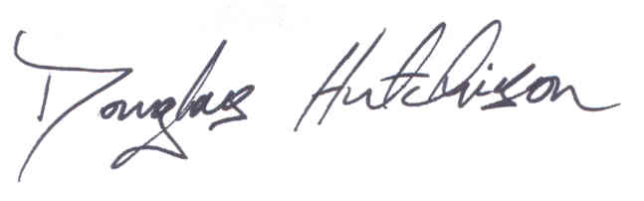

Douglas Hutchison
Depute Chief Executive and Director - People

