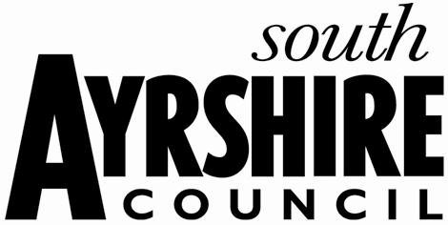
Purpose
The purpose of this paper is to promote the responsible use of social media and provide parents with a statement on acceptable use in relation to the work of the school. The statement is intended for parents by parents.
Introduction
The Parent Council recognises the value of social media in supporting the work of the school. As parents we know that social media represents a fundamental shift in the way we communicate with each other at work, home and school. However, it is important that we, as parents using social media, also understand the consequences as well as the benefits. The Parent Council also recognises that individuals are entitled to express themselves freely and that there are enormous benefits associated with parents using social media in support of the school. Social media can:
- Facilitate parental involvement in the life and work of the school
- Enhance communication between the school and parents
- Challenge traditional models of communication, making contact and dialogue easier
- Enable parents to collaborate online
Considerations
When communicating, posting or agreeing to comments electronically, parents should consider the impact this may have on children, staff and other parents. If parents identify themselves as members of the school community they should not act in a manner which might unintentionally bring the school or the Parent Council into disrepute.
Parents should also be aware that posting certain information or comments about the school, other parents, staff or children, may have unforeseen negative consequences for individuals and for the reputation of the school.
The Parent Council respectfully asks parents not to make comments of an abusive, harmful or offensive nature about individuals. Please consider the following questions before posting materials online:
- Might this comment reflect poorly on you, the children who attend the school, teaching staff or other parents in the local community?
- Are you confident that the comment, if accessed by others (parents, teachers, young people) would be considered reasonable and appropriate?
- Is your intention to post this material driven by personal reasons?
It is important to bear in mind that electronic messages are not anonymous and can be tracked and remain indefinitely on the internet. Social media sites archive content posted, even when deleted from online profiles. Once information is placed online, the author no longer controls it.
Thank you for your continued support in using social media appropriately to maintain the highest standards of communication in relation to the work of the school.

